Data Analysis

The data shows that charter schools have higher overall passing rates than their district(assuming, Public) schools. The data suggests that smaller charter schools spend the least per student and have higher, math, reading, and overall passing rates than their larger, more generous district counterparts.

District Summary

School Summary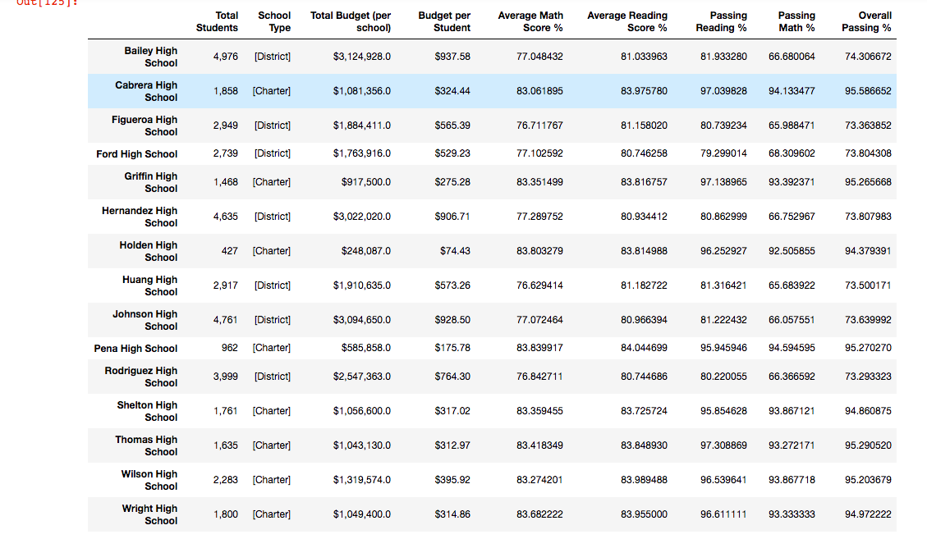

Top Performing Schools (by passing rate)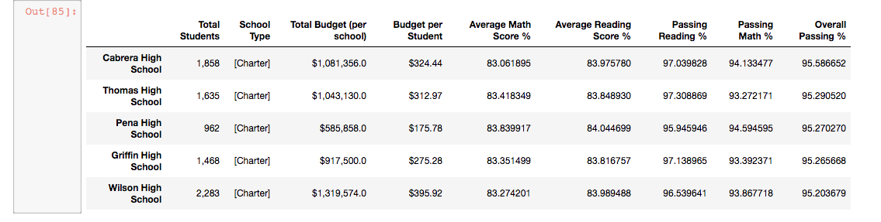

Bottom Performing Schools (by passing rate)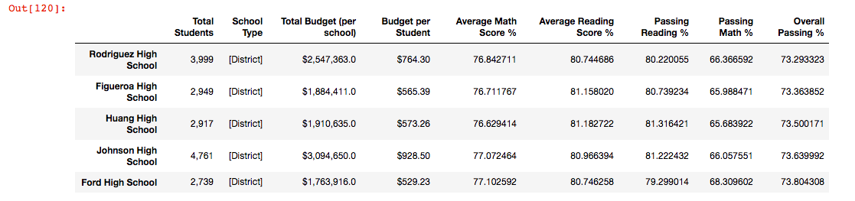

Math Scores by Grade 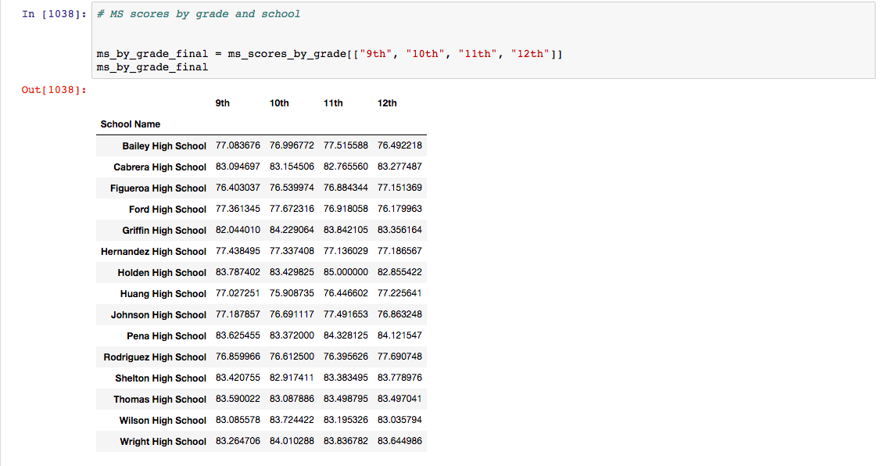

Reading Scores by Grade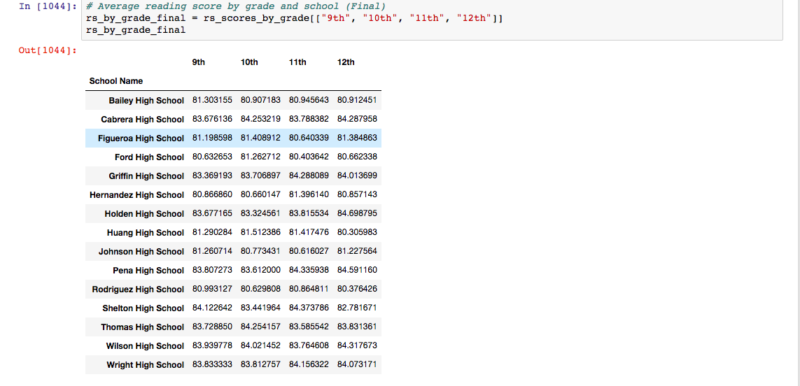

Scores by School Spending Range (per Student)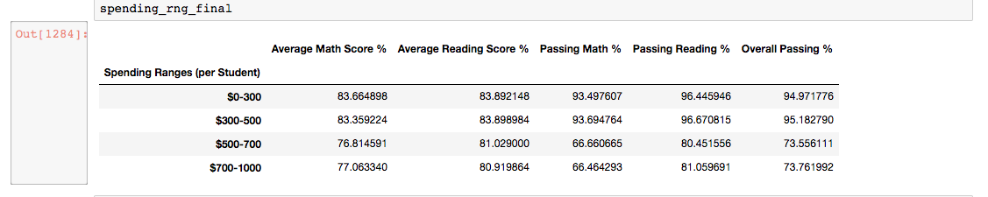

Scores by School Size (Small, Medium, Large)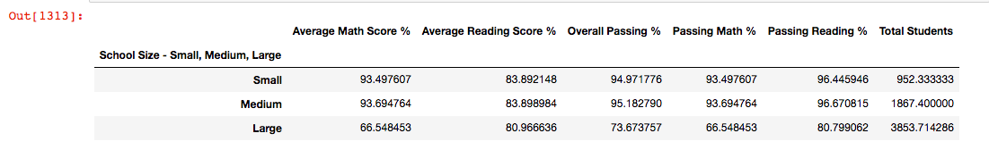

Scores by School Type (District, Charter)